HTML5

HTML is the step one for web development. In order to develop your own websites, you need to be familiar with this language. Since HTML5 is the latest version of HTML so this article will be based upon this.
So lets start.

PREREQUISITE

Any text editor can be used . All what HTML requires is a text editor and a web browser where you can render your code.

INTRODUCTION

HTML stands for HyperText Markup Language.
HyperText-The text which has hyperlinks in between it.
Markup Language- Language which specifies code for formatting

TAGS
Tags are the default words placed inside < > (Angular braces) and provide a particular structural element or styles related to it.
HTML tags normally come in pairs like <p> and </p>
The first tag in a pair is the start tag, the second tag is the end tag
The end tag is written like the start tag, but with a forward slash inserted before the tag name

Responsive Web Design - The Viewport

What is The Viewport?
The viewport is the user's visible area of a web page.
The viewport varies with the device, and will be smaller on a mobile phone than on a computer screen.
Before tablets and mobile phones, web pages were designed only for computer screens, and it was common for web pages to have a static design and a fixed size.
Then, when we started surfing the internet using tablets and mobile phones, fixed size web pages were too large to fit the viewport. To fix this, browsers on those devices scaled down the entire web page to fit the screen.

Setting The Viewport
HTML5 introduced a method to let web designers take control over the viewport, through the <meta> tag.
You should include the following <meta> viewport element in all your web pages:
<meta name="viewport" content="width=device-width, initial-scale=1.0">
A <meta> viewport element gives the browser instructions on how to control the page's dimensions and scaling.
The width=device-width part sets the width of the page to follow the screen-width of the device (which will vary depending on the device).
The initial-scale=1.0 part sets the initial zoom level when the page is first loaded by the browser.

HTML ELEMENTS
An HTML element usually consists of a start tag and end tag, with the content inserted in between:
<tagname>Content goes here...</tagname>
The HTML element is everything from the start tag to the end tag:
<p>My first paragraph.</p>

HTML ATTRIBUTES
- All HTML elements can have attributes
- Attributes provide additional information about an element
- Attributes are always specified in the start tag
- Attributes usually come in name/value pairs like: name="value"

For example: <p align=”center”>You are awesome </p>
Here align is an attribute of p tag.

GETTING STARTED
The statement to be mentioned in the begining of any HTML5 page is
<!DOCTYPE html>
(The above statement tells the browser that the page uses HTML5 language) which is to be followed by <html>

The first page of the website shall be named index.html as when we render the website, server searches for index.html and then opens it.

<!DOCTYPE html>
<html>
<head>
<title> My page </title>
</head>
<body>
<p> This is my first HTML page </p>
</body>
</html>

Head tag contains the meta data. It contains the title of the webpage, scripts, styling information etc.

Body tag contains all the text to be present it the webpage.

MOST USED TAGS

HTML Paragraphs
HTML paragraphs are defined with the <p> tag:

Example
<p>This is a paragraph.</p>
<p>This is another paragraph.</p>

HTML Links
HTML links are defined with the <a> tag:
The links can be in internal or external i.e you can connect to an external webpage using <a href> or even another part of the same webpage using internal linking.

Example
<a href="https://www.google.com">This is an external link</a>
<a href=”#top”> This is an internal link. </a>

HTML Images
HTML images are defined with the <img> tag.
The source file (src), alternative text (alt in case the image is not available to be presented on the webpage, this text would be displayed in its place), width, and height are provided as attributes:

Example
<img src="books.jpg" alt="Reading is good width="104" height="142">

src gives the source of the image i.e the address of the image.
Alt gives the alternate text.

HTML Lists

Unordered HTML List
An unordered list starts with the <ul> tag. Each list item starts with the <li> tag.
The list items will be marked with bullets (small black circles) by default:

Example
<ul>
<li>Pizza</li>
<li>Burger</li>
<li>Fries</li>
</ul>

Unordered HTML List - Choose List Item Marker

The CSS list-style-type property is used to define the style of the list item marker:
Value | Description
disc | Sets the list item marker to a bullet (default)
circle | Sets the list item marker to a circle
square | Sets the list item marker to a square
none | The list items will not be marked

Example - Disc
<ul style="list-style-type:square">
<li>Pizza</li>
<li>Burger</li>
<li>Fries</li>
</ul>

Ordered HTML List
An ordered list starts with the <ol> tag. Each list item starts with the <li> tag.
The list items will be marked with numbers by default:

Example
<ol>
<li>Coffee</li>
<li>Tea</li>
<li>Milk</li>
</ol>

EXAMPLE:
<!DOCTYPE html>
<html>
<body>

<h2>Unordered HTML List</h2>

<ul>
<li>Pizza</li>
<li>Burger</li>
<li>Fries</li>
</ul>

<h2>Ordered HTML List</h2>

<ol>
<li>Pizza</li>
<li>Burger</li>
<li>Fries</li>
</ol>

</body>
</html>
The output of the above code is:

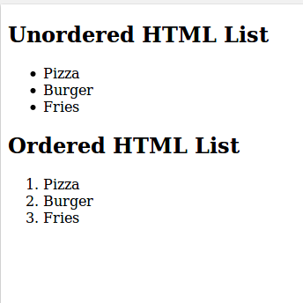

HTML Description Lists
HTML also supports description lists.
A description list is a list of terms, with a description of each term.
The <dl> tag defines the description list, the <dt> tag defines the term (name), and the <dd> tag describes each term:

Example
<dl>
<dt>Pizza</dt>
<dd>- farmhouse pizza</dd>
<dt>Burger</dt>
<dd>- vegetable cheese burger</dd>
</dl>

FOR EXAMPLE: I am trying this code
<!DOCTYPE html>
<html>
<body>

<h2>Discription HTML List</h2>

<dl>
<dt>Pizza</dt>
<dd>- farmhouse pizza</dd>
<dt>Burger</dt>
<dd>- vegetable cheese burger</dd>
</dl>
</body>
</html>
The output of the above code is:
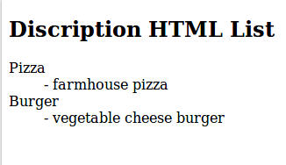

HTML Block and Inline Elements
Every HTML element has a default display value depending on what type of element it is. The default display value for most elements is block or inline.

Block-level Elements
A block-level element always starts on a new line and takes up the full width available (stretches out to the left and right as far as it can).
The <div> element is a block-level element.

Example
<div>Hello</div>
<div>World</div>

Below I have attached a screenshot of the code and the output attained.
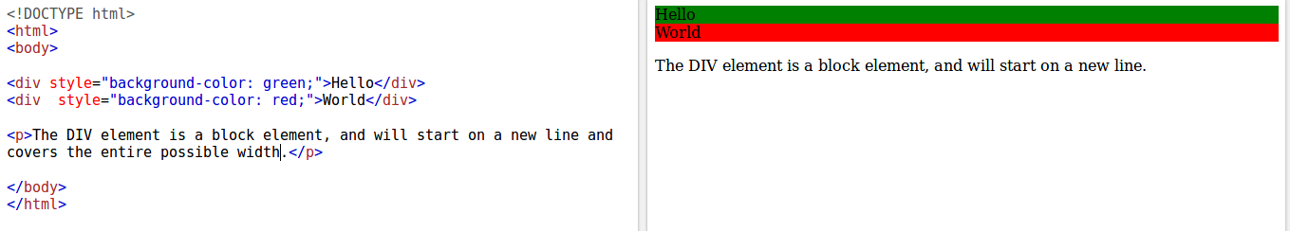

Inline Elements
An inline element does not start on a new line and only takes up as much width as necessary.
This is an inline <span> element inside a paragraph.
FOR EXAMPLE:
I am running the code below
<!DOCTYPE html>
<html>
<body>

<span style="background: red";>Hello</span>
<span style="background: green";>World</span>

<p>The SPAN element is an inline element, and will not start on a new line.</p>

</body>
</html>
The output i received is:
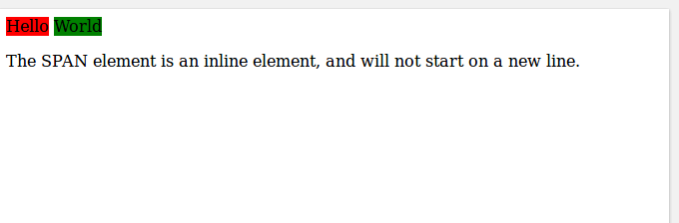

HTML IFRAME
Iframe is used to use a webpage inside a webpage.
<iframe src="URL"></iframe>
here URL is the URL of the page to be displayed inside our webpage.
Similarly iframe can be used to input a youtube video in your webpage.
For example: open the youtube video you want to embed in ypur webpage. Right click on the video and select embed video option and then select paste in your text editor.

We can set height, width, border etc properties to the iframe.

HTML TABLES

Tables can be created using HTML.
The main tags are -
1. <table></table> To initialize a table
2. <th></th> Column heading
2. <tr></tr> Table row
3. <td></td> Data to be entered in table row.

Below is an example of the table

<!DOCTYPE html>
<html>
<body>

<table>
<tr>
<th>Firstname</th>
<th>Lastname</th>
</tr>
<tr>
<td>Vishruty</td>
<td>Mittal</td>
</tr>
<tr>
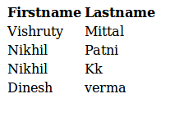
<td>Nikhil</td>
<td>Patni</td>
</tr>
<tr>
<td>Nikhil</td>
<td>Kk</td>
</tr>
<tr>
<td>Dinesh</td>
<td>verma</td>
</tr>
</table>
</body>
</html>

CSS
Cascading Stylesheets — or CSS is the first technology you should start learning after HTML. While HTML is used to define the structure and semantics of your content, CSS is used to style it and lay it out.

It is known as cascading because we can add stylesheets one over the other.

PREREQUISITE
You should have knowledge of HTML.

HOW TO APPLY CSS TO THE HTML FILE?
There are 3 methods to add CSS files to the HTML.
Below are the same:

1. INLINE STYLESHEET
When css is added inside the tag, it is inline styling.
Inline styling shall not be used though because in case we want to change the styling in later stages then it would become a hectic job to search for the desired tags in long codes and make the required changes.

2. INTERNAL STYLESHEET
When styles are defined in head tag of the page it is known as using the internal stylesheets. Using internal stylesheets is also discouraged because it does not promote text reuseability.

3. EXTERNAL STYLESHEETS
When we link external css files in the head section, it is known as using external stylesheets.It is the best practice.

HEIRARCHY
The order in which css files are preferenced is given below:
1. Inline
2. Internal
3. External
The above implies that if the same style attribute is mentioned in multiple css files then above is the order of preference. i.e if font-size is mentioned in all the three then the size mentioned in inline will be followed.

BOX MODEL

All HTML elements can be considered as boxes. In CSS, the term box model is used
when talking about design and layout. The CSS box model is essentially a box that
wraps around every HTML element. It consists of: margins, borders, padding, and
the actual content.
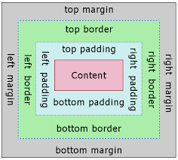

Explanation of the different parts:
Content - The content of the box, where text and images appear.
Padding - Clears an area around the content. The padding is
transparent.
Border - A border that goes around the padding and content.
Margin - Clears an area outside the border. The margin is transparent.

SOME BASIC CSS EXAMPLES
1. color
p{
color: red;
}
The above code changes the colour of the text within paragraph tag to red.

P{
background-color: green;
}
This will set the background colour to green.

2. Fonts
p{
font-size: 16px;
}
Will set font-size to 16px

p{
font-family: Arial;
}
Will set font to arial.

CSS SELECTORS
- Id selectors
- Class selectors
Id selectors
The id is used using #
for example:
<p id=”demo”>Hey guys </p>
The above is a line in HTML code and then in css we can edit it using:
#demo{
font-size: 12rem;
color: yellow;
}

Class selector
The class is used using .(dot)
for example:
<p class=”demo”>Hey guys </p>
The above is a line in HTML code and then in css we can edit it using:
.demo{
font-size: 12rem;
color: yellow;
}

Position Property
There are 5 types of position:
1. Static
2. Absolute
3. Relative
4. Sticky
5. Fixed

STATIC
Elements which are mentioned static are not affected by left, right,top,bottom properties.
i.e if the below code is used,
p{
position:static;
left:22px;
}
Then left will not matter i.e it would be ignored.

ABSOLUTE
It is positioned relative to the nearest positioned ancestor.

RELATIVE
It will be positioned according the attributes we define.
For eg.
p{
position:static;
left:22px;
}
Will assign it to the 22 pixels right of the left window pane.

STICKY
It will be scrolled up with the screen until the screen reaches the point where sticky was positioned and after that it will stick to the top of the window.

FIXED
It will be fixed at the same point even when we scroll the screen.
For eg if it was initially located at 20px from top then irrespective of scrolling, it will still be present at 20px from top.

FLOAT PROPERTY
Float property is assigned to the elements to make them break the normal flow.
Float can be
float: left;
float: right;
according to your styling needs you may use any.

Using float the element breaks its normal flow and makes a new stack.

DISPLAY PROPERTY

There are three types of Display:
1. Display-inline
2. Display-block
3. Display-inline- block

Display-inline: For inline elements display: inline is default. If we want to
make ant block elements inline, it can be made so using
display: inline
but the width cannot be setted manually

Display-Block : For block elements Display: block is default. If we want
to make inline element a block use
display: block
We can set user define width to it,but it still acts like a block element.

Display-Inline- block: If we want to give User Define Width to block elements
then this property maybe used.

960 Grid
The 960 Grid System is an effort to streamline web development workflow by providing commonly used dimensions, based on a width of 960 pixels. There are two variants: 12 and 16 columns, which can be used separately or together. 960 grid facilitates to make a website which is well structured and uses a universal framework.

In 12 column approach, the available width i.e 960 is divided into cells of 60 px width whereas in 16 column approach, the cells are 40px wide. 10px of gutter space is added before and after each cell. This results in 20px of space in between consecutive cells. The remaining pixels are distributed between left and right screen equally in form of gutter space.

When we merge columns i.e for eg. I take 5 cells for my work, then the 10px gutter space between those 5 cells is removed and can be used for our deeds.

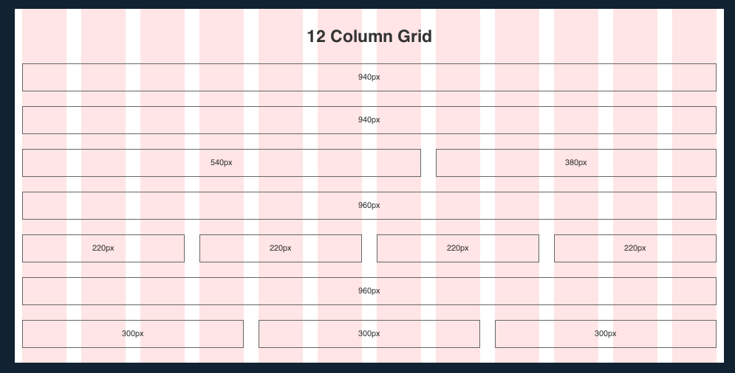
The above picture provides the information about how the cells are assigned spaces.

USING THE GRID SYSTEM
Using the grid system is easy to use. Infact it eases our work by a great amount, we no longer have to adjust margins manually.

We can download the files using https://960.gs/
After downloading we get mainly 3 files :

960.css
It contains the main css code which provides us the grid.

reset.css
It is reset file that accounts for browser quirks

text.css
It contains the built-in typography stylesheet

and make a separate file for your own style sheets

Here's a quick overview of the syntax, pulled from the 960.gs site:

<div class="container_12">
<div class="grid_7 prefix_1">
<div class="grid_2 alpha">
...
</div>
<div class="grid_3">
...
</div>
<div class="grid_2 omega">
...
</div>
</div>
<div class="grid_3 suffix_1">
...
</div>
</div>

The first div is your container, what your content will be stored in. By defining it's class as "container_12", you're saying: "I want this container to have a 12 column grid" (The same practice applies when using a 16 and 24 column grid).
Now that you've defined the container as a 12 column layout, you begin to structure your site in such a way that it fits within the layout. If you look at the next div elements in the hierarchy (as noted by the tabs), you'll see the syntax for their definitions. "Grid_7" and "grid_3" are easy enough to understand: you're saying that this div element is going to take up X number of columns. However, 7+3 = 10 < 12, which means you'll have 2 empty columns at the end of the container, right? Well, this is where the prefix and suffix aspect of the class definition come into play. With a class definition of "grid_x suffix_y", you're saying: "I want this div to take up X columns, and for there to be Y number of empty columns after it." (This also applies to prefix). So, since "Grid_7" has a prefix of 1, and "Grid_3" has a suffix of 1, 7+3+1+1 = 12!
By now, I know you're wondering about the Div elements nested in the "Grid_7" div. Well, you can nestle divs which take up a specified number of columns inside another div, so long as it does not exceed the size of its parent grid. Furthermore, the first and last elements must have "alpha" and "omega" appended to their class definition, respectively. So, in our sample code: "grid_2 alpha" is the first div nested within "grid_7", the next element "grid_3" is in the middle (and therefore does not need an "alpha" or "omega" appended to it), and finally "grid_2_ omega" is the last div nested within "grid_7". And since 2+3+2 = 7, the definition is proper.

